HEARING CONSERVATION ASHORE IN THE PACIFIC NORTHWEST


If you ask people here to imagine or recall “sounds of the Pacific Northwest,” they are likely to describe waves breaking on a beach, wind blowing through a forest, or the raucous cry of seagulls. Unfortunately, there is also a lot of noise originating at military facilities, a cornerstone of our robust economy. We have shipyards, firing ranges, construction sites, flight lines and many other areas and operations that expose us to hazardous noise at every turn. Sadly, many civilian workers, Sailors and Marines have developed the attitude that hearing loss “goes with the job.” They are the ones who either don’t fully insert their earplugs, or don’t use them routinely. The truth is that no worker, serviceman or servicewoman needs to lose hearing from his or her work environment. Since the late 1960s, the Navy has made hearing protectors available and mandated their use. The current selection of hearing protection is more comfortable than ever, fits virtually any ear canal size and shape, and reduces noise to safe levels if worn properly.

If you have problems inserting your disposable foam earplugs, ask one of the Branch Clinic health technicians or your corpsman to let you try a pair of the new 4-flange non-disposable earplugs or where available, the small and large sizes of disposable foam plugs. The Health Technician or corpsman will also provide an earplug case, and you will leave with new confidence in your personal protective equipment. Tool rooms should maintain a good supply of hardhat-mount earmuffs and other earmuff styles that some prefer to earplugs, or are necessary for double protection situations such as needle gunning in small spaces, sandblasting, or on the firing range. Earmuffs and cranials must be re-fitted with replacement ear cushions on a regular basis.

There are 5 basic elements to the Navy Hearing Conservation Program:
1) Sound level survey to identify noise hazardous equipment and spaces, which are then posted/labeled to alert the need for personal hearing protection. A good rule of thumb is that sound is probably hazardous if you have to raise your voice to converse from 3 feet away.
2) Engineering controls to quiet noise sources and make hearing protection unnecessary. NAVSEA and NAVFAC are primarily responsible for this function, although our industrial hygienists have made useful improvements locally.
3) Enroll exposed workers in a hearing conservation program which uses reference and annual monitoring audiograms to identify noise-induced changes in hearing at the earliest possible interval – typically before the shift becomes permanent or can interfere with communication. Upon detecting a significant threshold shift (STS), Medical Department personnel will take actions to include refitting of personal hearing protection and if necessary, referral to an audiologist for evaluation and case management.
4) Provide personal hearing protection to reduce noise exposure to safe levels.
5) Initial and annual education. We are taking care of that right now.

Why is noise induced hearing loss such a big problem in industrial and military settings? Because of the 4 P’s:
- It is PAINLESS, PROGRESSIVE, PERMANENT…..and it is PREVENTIBLE

While sound/noise has the potential to damage your hearing at 85 decibels (about the loudness of your blender or vacuum cleaner), most people don’t feel pain until 130-140 dB (a jet engine at takeoff). To put it into perspective, a large truck with windows open may expose the driver to 83-85dB, a level that is fairly safe for up to 8 hours or so without hearing protection. However, a pipefitter grinding on metal or a Machinist Mate in main propulsion spaces usually experiences no pain in their 95 to 110 dB environment, yet if exposed for an extended period without hearing protection, is at high risk for noise induced hearing loss. Workers may tell you they “get used to the noise.” Nope. They get deaf.

(Answers from page 2: 1-F, 2-d, 3-a, 4-d, 5-T)
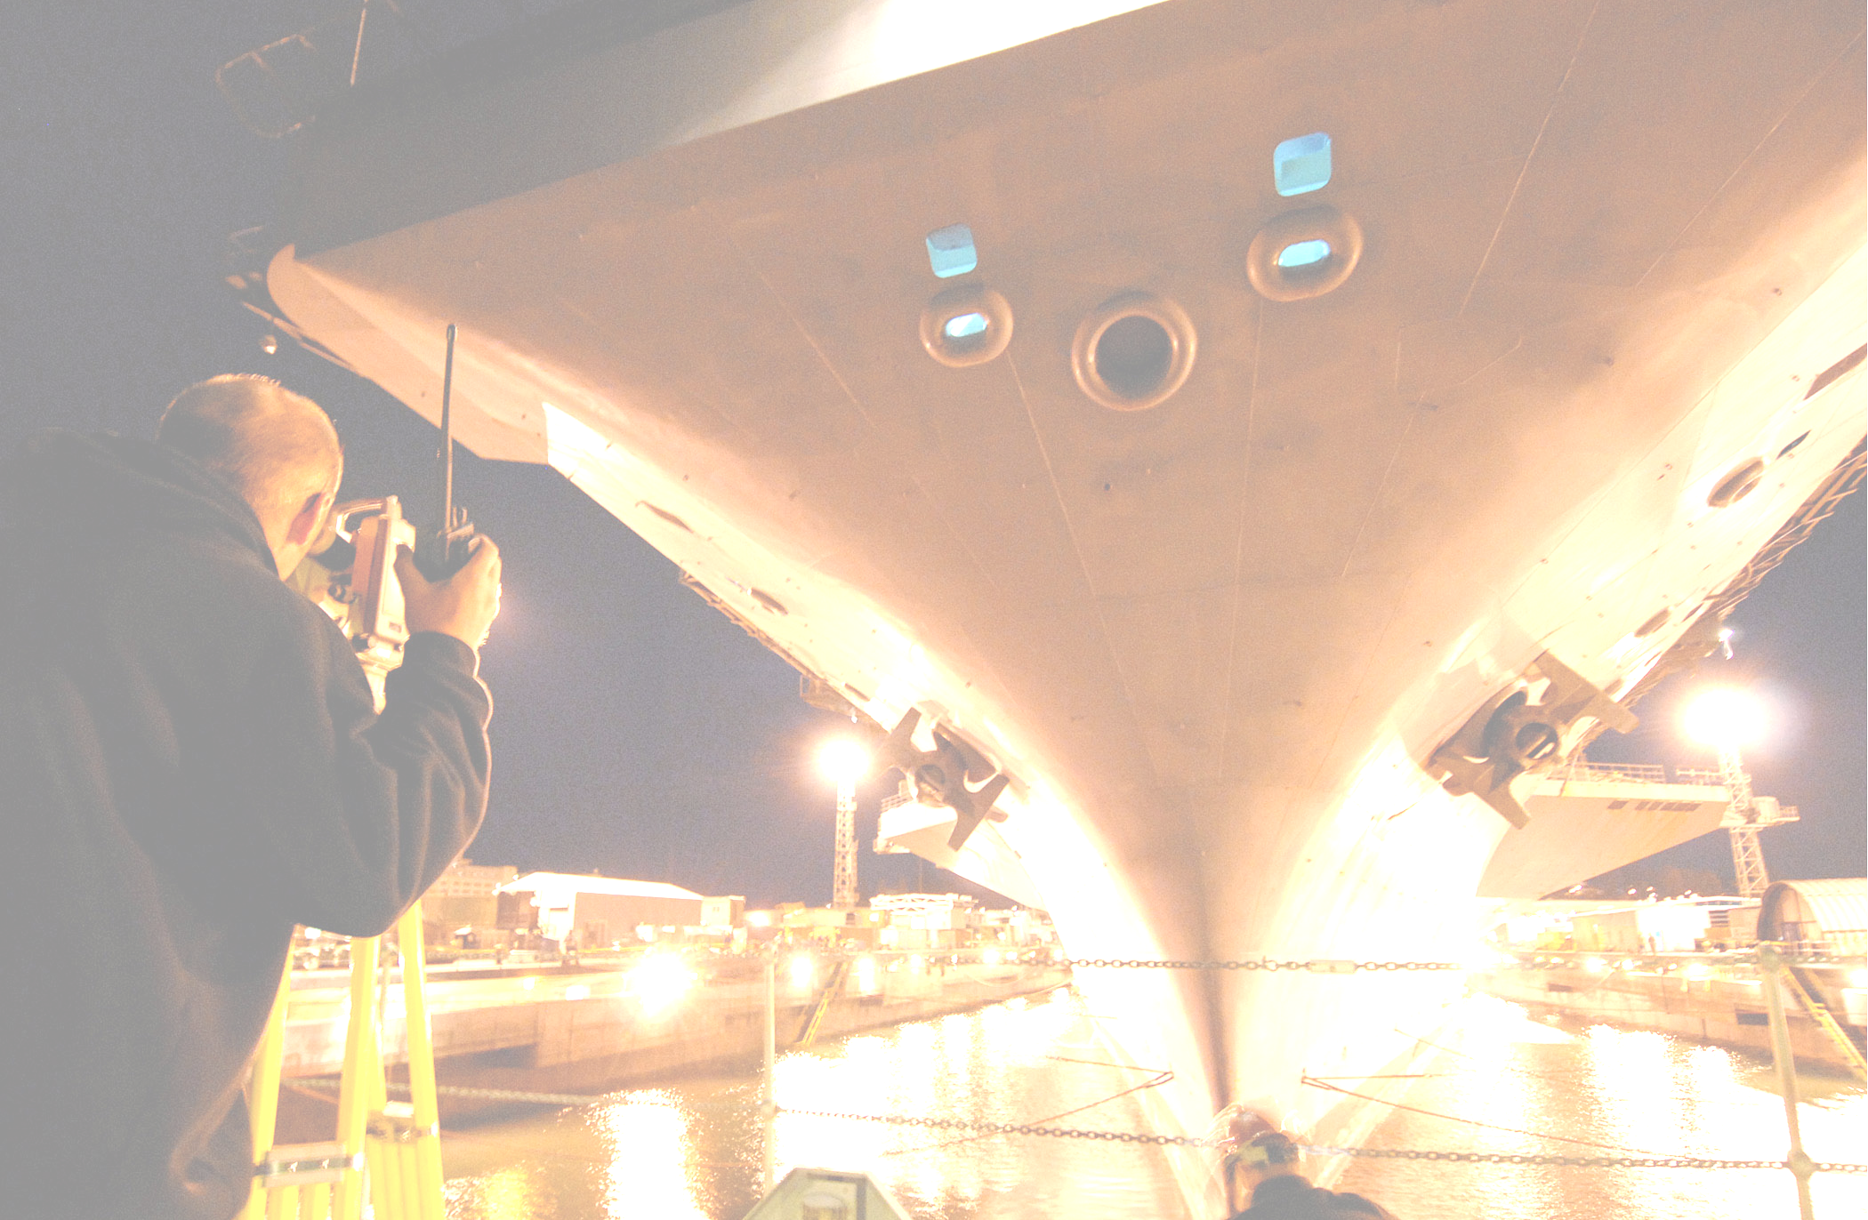
There are about 30,000 microscopically small receptor cells for hearing (termed hair cells) in each inner ear. When over-exposed to noise, those cells are initially bruised and battered, causing a temporary hearing loss and often tinnitus (a buzzing or ringing sound in the ear). If the exposure is loud enough for long enough, the hair cells can die and a region of hearing is permanently damaged – typically high frequencies. With 30,000 cells to begin with, it may take many years of unprotected exposure to industrial or operational noise before there is sufficient damage to interfere with speech under good listening conditions. Unprotected exposure to weapons fire can cause instantaneous permanent hearing loss. Early signs of damage include tinnitus, a blocked or stuffy feeling in the ears, problems understanding speech in background noise or when listening to female or child voices, and certainly changes in hearing noted on the annual monitoring audiogram. Almost every male worker referred for evaluation of permanent threshold shift will tell of his wife’s complaints that he is ignoring her. Nope again. A woman’s voice is at a higher pitch than a man’s, moving more of her speech into the area damaged by noise.

What about the person who has already lost appreciable amounts of hearing through noise exposure and/or aging? Is it too late to do anything else except file a claim and go get your hearing aids? Absolutely not! Remember the PROGRESSIVE component of this type of hearing loss and protect the hearing you have left. It is very likely that you can keep your hearing at a level that either does not need hearing aids or will derive good benefit from them. In the latter stages of noise induced hearing loss, hearing aids cannot return your hearing anywhere close to the sensitivity you enjoyed when you first concluded that hearing protection was either too much trouble or unnecessary.

One more thought. Your hearing is equally at risk from amplified music, woodworking tools, chain saws and lawnmowers, or most motorcycles as it is from a gas turbine diesel or needlegunning. If sound is loud enough for long enough, it will hurt you! We hope that armed with this information you can have a long and productive career here in the beautiful Northwest, and retire with your hearing health intact. It is really up to you!

REVIEW QUESTIONS

1) T or F: Noise must be painful before it can harm hearing.

2) The best hearing protector for me is:
a. The Sound Guard disposable foam earplug
b. The blue 4-flanged earplug
c. The small or large size foam earplugs
d. Whichever plug fits the best and is most comfortable

3) Female & child voices are harder to hear than male voices
because:
a. They are a higher pitch & noise damages high pitches
first
b. Females/children are usually shorter, sound travels
along the ground
c. The statement is not true

4) Which sound source has the greatest potential to harm hearing?
a. A large grinder putting out 90 decibels
b. An IPOD playing Barry Manilow at 90 decibels of
loudness
c. A Harley Davidson Sportster measured at 90 decibels
at rider’s ear level
- All the same risk, depends simply on the length of time
one is exposed (OK, Barry Manilow might be a bit
more painful)

- T or F: One shotgun round can cause permanent hearing loss.

(answers on bottom of preceding page)

.

